# Create Database

IF OBJECT_ID('dbo.CarRental') IS NOT NULL BEGIN

DROP DATABASE CarRental;

END;

ELSE

CREATE DATABASE CarRental;

# Create Tables

USE CarRental

IF OBJECT_ID('dbo.Store', 'U') IS NOT NULL

DROP TABLE dbo.Store;

IF OBJECT_ID('dbo.Midsize', 'U') IS NOT NULL

DROP TABLE dbo.Midsize;

IF OBJECT_ID('dbo.Payment', 'U') IS NOT NULL

DROP TABLE dbo.Payment;

IF OBJECT_ID('dbo.SUV', 'U') IS NOT NULL

DROP TABLE dbo.SUV;

IF OBJECT_ID('dbo.Truck', 'U') IS NOT NULL

DROP TABLE dbo.Truck;

IF OBJECT_ID('dbo.Vehicle', 'U') IS NOT NULL

DROP TABLE dbo.Vehicle;

IF OBJECT_ID('dbo.Customer', 'U') IS NOT NULL

DROP TABLE dbo.Customer;

IF OBJECT_ID('dbo.Rental', 'U') IS NOT NULL

DROP TABLE dbo.Rental;

IF OBJECT_ID('dbo.Compact', 'U') IS NOT NULL

DROP TABLE dbo.Compact;

CREATE TABLE Store (

StoreID int NOT NULL PRIMARY KEY,

StoreCity varchar(50) NOT NULL,

StoreZip int NOT NULL,

StoreState varchar(2) NOT NULL

);

CREATE TABLE Customer (

CustomerID int NOT NULL PRIMARY KEY,

CustomerFName varchar(50) NOT NULL,

CustomerLName varchar(50) NOT NULL,

CustomerAddress varchar(50) NOT NULL,

CustomerCity varchar(50) NOT NULL,

AptNum varchar(10),

CustomerState char(2) NOT NULL,

CustomerZip int NOT NULL,

CustomerPhone varchar(10) NOT NULL,

CustomerEmail varchar(100),

LicenseID varchar(30) NOT NULL,

LienseExpiration date NOT NULL

);

CREATE TABLE Rental (

RentalID int NOT NULL PRIMARY KEY,

CustomerID int NOT NULL,

PaymentID int NOT NULL,

StoreID int NOT NULL,

VehicleID int NOT NULL,

RentalStartDate date NOT NULL,

RentalReturnDate date,

MilesDriven int,

InsuranceAmount MONEY NOT NULL,

LateFeeDays int,

LateFeePrice MONEY

);

CREATE TABLE Payment (

PaymentID int NOT NULL PRIMARY KEY,

RentalID int NOT NULL,

PaymentBalance MONEY NOT NULL,

PaymentMade MONEY,

PaymentType varchar(30)

);

CREATE TABLE Vehicle (

VehicleID int NOT NULL PRIMARY KEY,

VehicleType varchar(50) NOT NULL,

Make varchar(50) NOT NULL,

Model varchar(50) NOT NULL,

VehicleYear int NOT NULL,

Mileage int,

LicensePlace varchar(6) NOT NULL,

VinNumb varchar(100) NOT NULL,

RentalPrice MONEY

);

CREATE TABLE Truck (

VehicleID int NOT NULL PRIMARY KEY,

BedSize varchar(3)

);

CREATE TABLE SUV (

VehicleID int NOT NULL PRIMARY KEY,

TowLimit int

);

CREATE TABLE Compact (

VehicleID int NOT NULL PRIMARY KEY,

MaxPassenger int

);

CREATE TABLE Midsize (

VehicleID int NOT NULL PRIMARY KEY,

FoldableSeats BIT

);

# Insert Data Into Tables

USE CarRental;

TRUNCATE TABLE Compact;

TRUNCATE TABLE Customer;

TRUNCATE TABLE Midsize;

TRUNCATE TABLE Payment;

TRUNCATE TABLE Rental;

TRUNCATE TABLE Store;

TRUNCATE TABLE SUV;

TRUNCATE TABLE Truck;

TRUNCATE TABLE Vehicle;

INSERT INTO Compact

(VehicleID, MaxPassenger)

VALUES

(5, 5),

(6, 5);

INSERT INTO Customer

(CustomerID, CustomerFName, CustomerLName, CustomerAddress, CustomerCity,

AptNum, CustomerState, CustomerZip, CustomerPhone,

CustomerEmail, LicenseID, LienseExpiration)

VALUES

(1, 'Bob', 'Smith', '120 Main Street', 'Mankato',

NULL, 'MN', 56001, 5077776666,

'bob.smith@gmail.com', '56TGHY67JNHYU8I9', '20210410'),

(2, 'Eugine', 'Burger', '22 Penny Lane', 'New York',

NULL, 'NY', 99880, 6789879943,

NULL, '3WWI95827FKPLMQ8', '20200331'),

(3, 'Marie', 'Ann', '1200 Cedar Place', 'Tampa',

'102B', 'FL', 87766, 2334326987,

'marie22@hotmail.com', '9JJ59WKH03ZMT9WI', '20300101'),

(4, 'Susan', 'Tompson', '565 Maple Lane', 'St. Paul',

NULL, 'MN', 55304, 4435789900,

'susan.tompson@gmail.com', '384JGH39TURJVNDJ', '20190701')

INSERT INTO Midsize

(VehicleID, FoldableSeats)

VALUES

(7, 1),

(8, 0)

INSERT INTO Payment

([PaymentID]

,[RentalID]

,[PaymentBalance]

,[PaymentMade]

,[PaymentType])

VALUES

(1, 1, 450, 0, NULL),

(2, 2, 330, 100, 'Credit')

INSERT INTO Rental

([RentalID]

,[CustomerID]

,[PaymentID]

,[StoreID]

,[VehicleID]

,[RentalStartDate]

,[RentalReturnDate]

,[MilesDriven]

,[InsuranceAmount]

,[LateFeeDays]

,[LateFeePrice])

VALUES

(1, 1, 1, 1, 1, '20170331', '20170425',

300, 5000, NULL, NULL),

(2, 2, 2, 2, 1, '20170402', '20170412',

75, 4750, 3, 50),

(3, 3, 3, 1, 6, '20170506', '20170606',

322, 3200, NULL, NULL),

(4, 4, 2, 2, 5, '20170404', '20170408',

298, 1000, NULL, NULL)

INSERT INTO Store

([StoreID]

,[StoreCity]

,[StoreState]

,[StoreZip])

VALUES

(1, 'Mankato', 'MN', 56001),

(2, 'Sacramento', 'CA', 10223)

INSERT INTO SUV

(VehicleID, TowLimit)

VALUES

(3, 1500),

(4, 2000)

INSERT INTO Truck

(VehicleID, BedSize)

VALUES

(1, '4x4'),

(2, '6x4')

INSERT INTO Vehicle

([VehicleID]

,[VehicleType]

,[Make]

,[Model]

,[VehicleYear]

,[Mileage]

,[LicensePlace]

,[VinNumb]

,[RentalPrice])

VALUES

(1, 1, 'Ford', 'F-150', 2016, 40356, 'VFT435', '7564829047', 200),

(2, 1, 'Chevrolet', 'Silverado', 2012, 76882, 'BUU871', '8493088295', 180),

(3, 2, 'Honda', 'CR-V', 2014, 56778, 'NNC221', '6648229687', 145),

(4, 2, 'Mazda', 'CX-5', 2014, 65790, 'YQQ509', '8712823318', 175),

(5, 3, 'Kia', 'Soul', 2017, 2901, 'POI113', '1422538693', 210),

(6, 3, 'Chevrolet', 'Bolt', 2016, 43112, 'CVW544', '7559300254', 185),

(7, 4, 'Toyota', 'Camry', 2015, 74338, 'MJJ964', '5527384122', 160),

(8, 4, 'Nissan', 'Altima', 2016, 45663, 'QVB990', '7744928675', 180)

# Join SQL

The SQL statement joins the Customer and Rental tables to show the first and last names of all customers along with the vehicle ID number of the cars rented, where the customer is from Minnesota.

SELECT c.CustomerFName, c.CustomerLName, Rental.VehicleID

FROM Customer AS c

INNER JOIN Rental

ON c.CustomerID = Rental.CustomerID

WHERE c.CustomerState = 'MN';

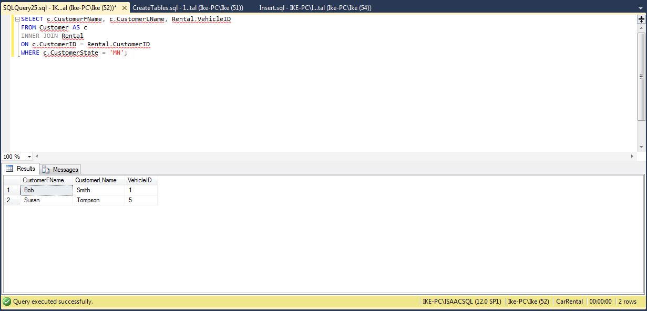

# Relationship Diagram

